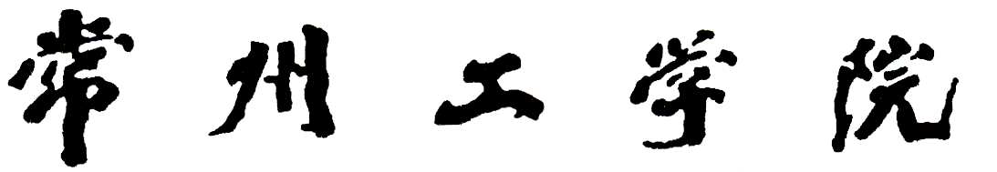

CHANGZHOU INSTITUTE OF TECHNOLOGY
课程设计个人报告
课程名： Java课程设计
题 目： 图书馆管理系统
二级学院： 计算机信息工程学院
班 级： 16 软件（国际）
组 号： 第 一 组
学 号： 16210525

姓 名： 特穆
指导教师： 蒋巍

2019年 7 月
Introduction
With the progress of society and the wide application of information technology, the advantages of digital management are becoming more and more obvious. In view of the backward management of small and medium-sized libraries or libraries, a library information management system is designed and implemented. The management of various books and information in small and medium-sized libraries or libraries can bring different conveniences to administrators and users through the combination of computers: quick retrieval, convenient search, high reliability, large storage capacity, good confidentiality, long life, low cost and so on. These advantages can greatly improve the efficiency of work, but also the library and other departments of scientific management, one of the important signs of regularization. Moreover, the cost of computer management is decreasing. Therefore, it is necessary to develop such a small and medium-sized library management software, and realize the principle of research serving practice.
The goal of this software is to make the management of library management system electronic, systematic and simple, so to save unnecessary waste of resources in Library management. The end users of the management system are end users, managers and other relevant personnel. This system includes the general functions of Library management. It also includes some other system functions, such as new book publishing, old book processing and reminder. The objectives also include:
1. Reduce the use of human resources and management costs; improve the accuracy and reliability of information;
2. Improve the management and personnel services in the library;
3. Establish an efficient information transmission and service platform to improve the speed and utilization of information processing;
4. System design is excellent, interface design is exquisite, friendly, fast, humanized design, background management function is powerful and efficient;
5. A simpler and more informative library management process;

Working in team and my part of work
Working in a team could prove to be an incredible learning experience when there is a readiness among the members to share information with one another; each member trusts and supports each other and also there is a willingness to stand by one another in time of crisis.
To make a team successful, there are several factors that are responsible for it. Some of them are:
- A clear understanding of the team’s mission
- Commitment towards the goals
- Predefined roles and responsibilities
- Proper decision-making process
- Agreed upon ground rules
- Productive group working process
So, after building the library information management system we start to discuss the responsibility to each team member and I took to make the front-end(interface) of the program and book details, main layer, register student classes.

- Front-End (Interface)
I decided that the interface should be extremely simple and beautiful. So, that any user, even who don’t have any advanced skills of using computer, can understand what is the program he is going to use and understand where to go to do the action that he want to do. For example, adding new book or student, look for list of issued books, select the specific information from the table using search engine, etc.. In addition, interface should not be very complicated and have much different colors. So, I decided to use “JFrame” framework and soft blue as a main color. I know that “java.swing” library has class “UIManager”, which has theme that perfectly combine with my idea. So I applied the theme “Nimbus”.
To centralize every window I wrote the “WindowUtils” class that get the size of monitor and calculate the center position.
To do using of our program more comfortable and reduce the amount of clicks to finish some operation for user, decided to add navigation bar to every window (page). It consist from the home button and other buttons that could be useful to user.
In the main layer there are some major buttons (Book details, issue book, return book, manage books, student details, issued book details). Also, there are three pictures above the three main buttons to illustrate their action and that they are the most significant.

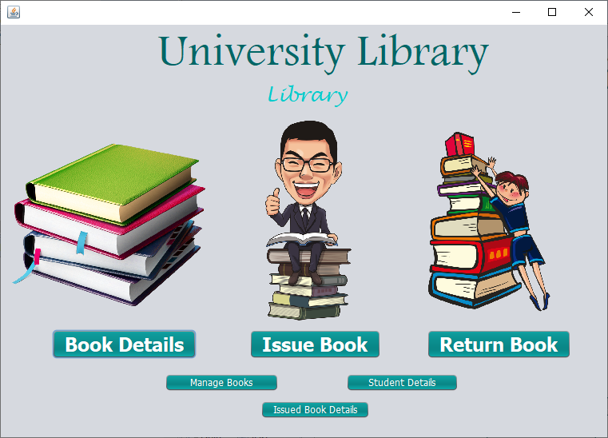
MainLayer
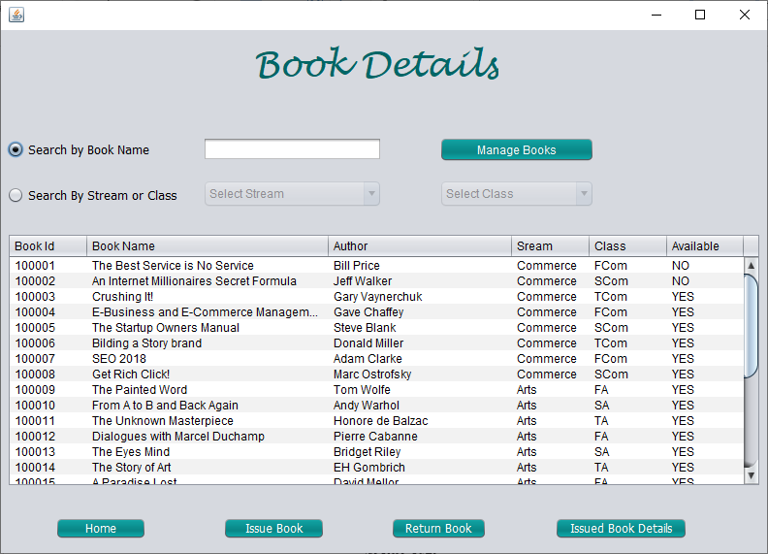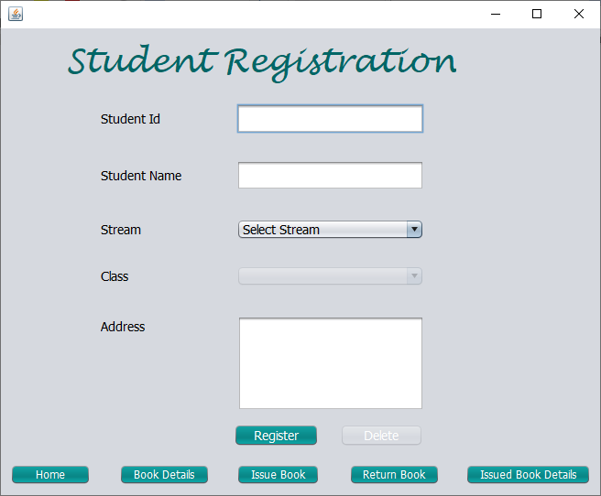
Other windows
- Book Details class
Book details window has a navigation bar as other windows. It has search engine block, which consist of one TextField, two RadioButtons and two ComboBoxes.
TextField enable only when the “Search book by name” radioButton is selected. TextField has a KeyReleased event which is trigger when user type a symbol in it and this KeyReleased event connect with database and send request to it to get the information about searched books.
Another RadioButton (“Search by Stream or Class”) enable “Select Stream” ComboBox to allow selecting and searching book’s stream. After selecting the stream, it activate “Select Class” ComboBox. So user can search by stream or class or by stream and class.
In addition, there is the table with columns (Book id, Book name, Author, Stream, Class, Available). It used to display the information about books.
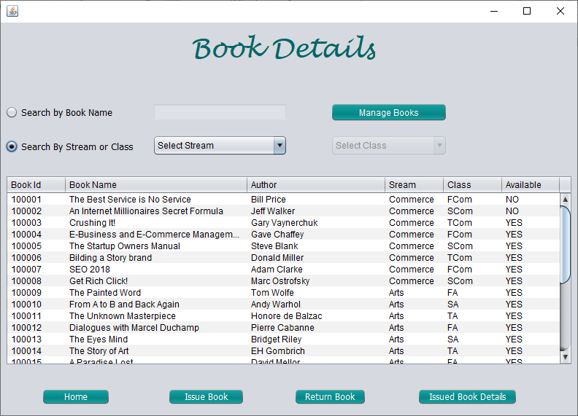
Book Details form

- Register Student class
This class also has navigation bar, Student ID textfield, Student name textfield, Stream combobox, Class combobox, Address textarea, Register button and delete button.
Student ID textfield has it’s own KeyReleased event, which work same like “Search Book by Name” textfield. KeyReleased event which is trigger when user type a symbol in it and this KeyReleased event connect with database and send request with Student ID to it, to get the information about student. After that, it print the student’s information in other window components. If there is no any student with this ID, User can register new Student after writing all necessary information. But if, there is the student in the database and his information printed to window components, than the register button will change to “Update” button. Update button has it’s own event. Also Delete button will be enabled.
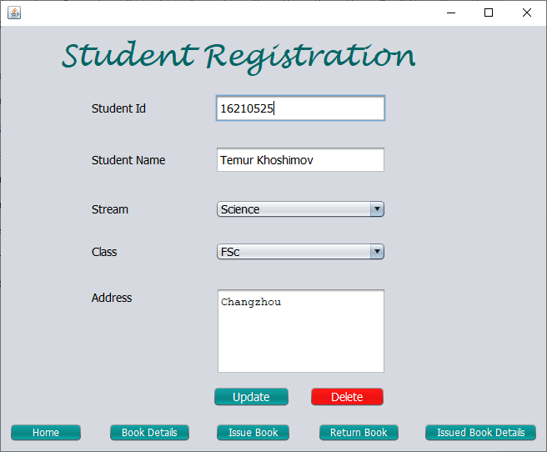
Student Registration
CONCLUSION
In the process of working in a team. I can prove that I get an incredible learning experience. Especially, I learned how to apply the theme to the JFrame projects and I deeply learned how to effectively work with database via java code. This project let me understand how is the team communication and work in team is necessary for final product. I learned that each member should trusts and supports each other and also there is a willingness to stand by one another in time of crisis.
The library management system is great project that I have done. I think that this project extend my knowledge about how to build the architecture of the program in team and how to design big software product which users can simply use.

